***Experiment : Door Bell***

**Concept used :-**

This experiment shows the working of the doorbell using buzzer by Arduino.

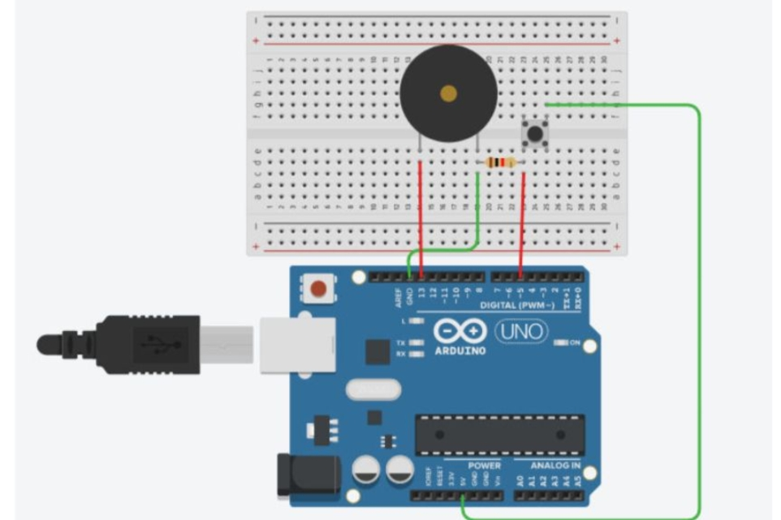The circuit consists of 2 digital pins .first pin 7 is used for making connection of buzzer with Arduino and further making the connection to the ground. One end of the switch is connected to 5V supply and intersection of pin 12 and switch is connected to resistor which is connected to ground from another end.

In this circuit the value of resistance is very high. So the resistors are used to resist the flow of current coding is done in such a way that when the switch is pressed the buzzer starts making sound and again when switch is pressed buzzer ,it will does not make any sound.

**Learning and observations :-**

1. Basic understanding of the electrical connection.
2. Making circuits with arduino.
3. Working of arduino UNO.
4. Ground has the least resistance.
5. Coding to be done on the ardunio.exe for the stimulation of the exper
6. How does toggling works.

**Problems and Troubleshooting :-**

1. Making correct connections.
2. Using multimeter to check whether all the devices are in working condition or not.
3. Correct sets of instruction are provided or not to perform the specific function.
4. Port selection for Arduino can also be incorrect .

**Learning Outcomes:-**

1. Setup correct connections to the Arduino.
2. Connecting switch, buzzer and Arduino .
3. Working and coding of Arduino .

**Result:-**

Working of buzzer and switch verified after uploading the program.